Hamstrings activation and the Squat
In the latest years a lot of emphasizes has been given to combine injury prevention and sport performance Beardsley (2013). Researches have shown that hamstring injuries are one of the most common injuries in sports (Ebben 2009). It is hypothesized that the role of the hamstring is to stabilize the knee (Isear et al., 1997). If the hamstrings do not generate forces in the eccentric part of the movement to counteract the deceleration of the concentric part injury may occur (Cheung et al., 2012). Weak hamstrings or low ration between hamstrings to quadriceps strength are mainly what cause hamstring injuries. Moreover a weakness in the hamstring group can result to an injury to the anterior crucial ligament (ACL) (Ebben, 2009). The ACL and the hamstrings prevent the anterior translation of the tibia on the femur, which happens in actions such as landing, sudden changing of direction etc. ( Cheung et al., 2012). Coaches and sports scientists have tried to develop programs and exercises to target hamstring muscles activation, strength and hypertrophy.
Ebben (2009) used a variety of exercises trying to identify which will activate maximally the hamstring group, as well as to identify hamstrings to quadriceps ratio. Researches used 34 ( 21 men and 13 women) athletes of NCAA DIVISION I AND DIVISION III. Subjects were tested on their hamstrings and quadriceps maximum voluntary isometric contraction (MVC) at 60 degrees of knee flexion. The exercises that were used were a 6RM on squat, seated leg curl, stiff leg deadlift, single leg stiff leg deadlift, good morning, and Russian curls.
From the EMG analysis it was found that Russian curls had the greatest activation, followed the seated leg curl, stiff leg deadlift, single leg stiff leg deadlift, good morning, and squat (Figure 1). 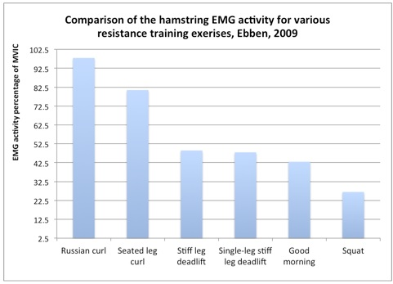
Figure 1 (in Beardsley 2013).
Moreover they found that the back squat exercise had hamstrings to quadriceps of 0.37:1. This ratio shows that the back squat had a 2.7 times greater quadriceps activation compared to hamstrings.Other studies have looked at hamstring activation during back squat compared to other muscles groups especially the quadriceps. A study by McCaw et al. (1998) found that when using 75 % of 1RM of the back squat hamstring activation was the lowest with the highest being the quadriceps group (figure 2).
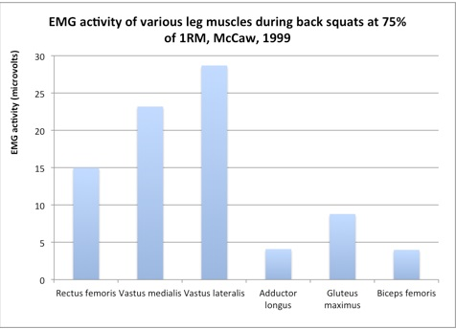
Figure 2 (in Beardsley 2013).
Wright et al. (1999) conducted a similar study comparing peak EMG activity during the leg curl, stiff leg deadlift. They measured peak voluntary isometric contractions of the semitendinosus and bicep femoris. The EMG findings showed that the back squat had half of the activation than the leg curl and stiff leg deadlift (figure 3).
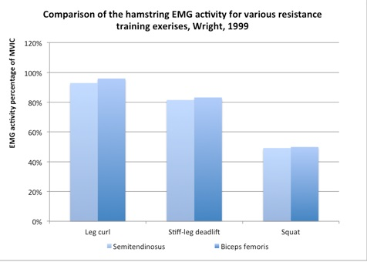
Figure 3 (in Beardsley 2013).
Escamila et al. (1998) investigated the difference of hamstring activity in squats, and knee extension. Their EMG results showed twice hamstring activation in squat. Paoli et al. 2009 concluded that a normal stance back using 70% of 1RM did not significantly recruited more hamstrings muscle compared to the quadriceps, thus making the squat a quad dominant exercise ( Figure 4)
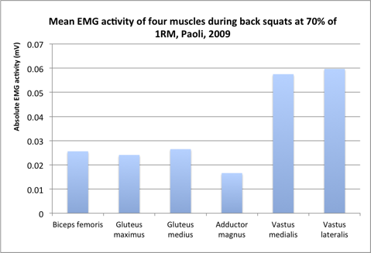
Figure 4 (in Beardsley, 2013).
Jensen and Ebben (2000) studied the relationship between squat depth and hamstring motor unit activity using an EMG. The results showed no difference during the concentric part of the lift, but during the eccentric phase the hamstring were activated more when knee flexion was 120ºor less. The conclusion from this research was that hamstring activation and contribution is greater during the eccentric phase of the lift rather than the concentric, as well as hamstring activity is increasing as depth is increasing.
McAllister et al. (2014) studied bicep femoris and semitendinosus during the eccentric and concentric part of the Romanian deadlift (stiff leg deadlift), leg curl, good morning, and glute-ham raise. The main findings of the study were that semitendinosus was more active than the bicep femoris during all the exercises, and that hamstring activity was maximized during the Romanian deadlift and the glute-ham raise.
Training the hamstrings, and keeping a balanced ratio of hamstrings to quadriceps group is really important for sport performance and injury prevention. The squat exercise exercise was believed to be an exercise that develops hamstring strength. Nonetheless, research have shown that the squat has been mainly a quad dominant exercise, where the contribution of the hamstrings group is minimal compared to other muscles groups. The exercises that demonstrated greater muscle activation were the Russian curl, seated leg curl, and stiff leg deadlift. With no doubt squat is a muscle and strength building exercise, but the squat itself is not enough for building strength of the hamstrings muscles, or use it as an injury prevention exercise. Other more isolated exercises should be included in training programs. Research demonstrated that the hamstrings were activated significantly more during the eccentric phase of the exercises.
References
Beardsley , C. (2013) How important are the hamstrings during squats?. [Online] Available from: http://www.strengthandconditioningresearch.com/2013/04/30/hamstrings-squats/ [accessed 16 May 2014]
Cheung, R.T.H., Smith, A.W. and Wong, D.P. (2012) H:Q Ratios and Bilateral Leg Strength in College Field and Court Sports Players. Journal of Human Kinetics. Vol. 33: 63-71.
Ebben, W.P. (2009) Hamstring Activation During Lower Body Resistance Training Exercises,. International Journal of Sports Physiology and Performance. Vol. 4, No. 1: 84-96.
Ebben, W.P. and Leigh, D.H. (2000) October 2000Strength and Conditioning Journal15 The Role of the Back Squat as aHamstring Training Stimulus. National Strength & Conditioning Association. Vol. 22, No. 5: 15-17.
McAllister, M.J., Hammond, K.G., Schilling, B.K., Ferreria, L.C., Reed, J.P. and Welss, L.P. (2014) Muscle activation during various hamstring exercises. Journal of Strength & Conditioning Research. Vol. 1
McCaw, S.T. and Melrose, D.R. (1999) Stance width and bar load effects on leg muscle activity during the parallel squat. MEDICINE & SCIENCE IN SPORTS & EXERCISE. Vol. 1: 428-436.
Paoli, A., Marcolin, G. and Petrone, N. (2009) The effect of stance width on the electromyographical activity of eight superficial thigh muscles during back squat with different bar loads.. Journal of Strength and Conditioning Research. Vol. 23, No. 1: 246-250.
Wright, G.A., Delong, T.H. and Gehlsen, G. (1999) Electromyographic Activity of the Hamstrings During Performance of the Leg Curl, Stiff-Leg Deadlift, and Back Squat Movements. Journal of Strength and Conditioning Research. Vol. 13, No. 2: 168-174.

